SAP – RECEIVE A SHIPMENT
When a manifest is raised heading to Seagull, a SAP manifest number is issued. We have to receive the manifest when we get the vessel in field. You can not receive part of the manifest it all comes.

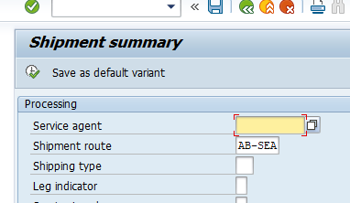
AB-SEA is the default option (Aberdeen to Seagull)
Click
Use code o3o_sr10

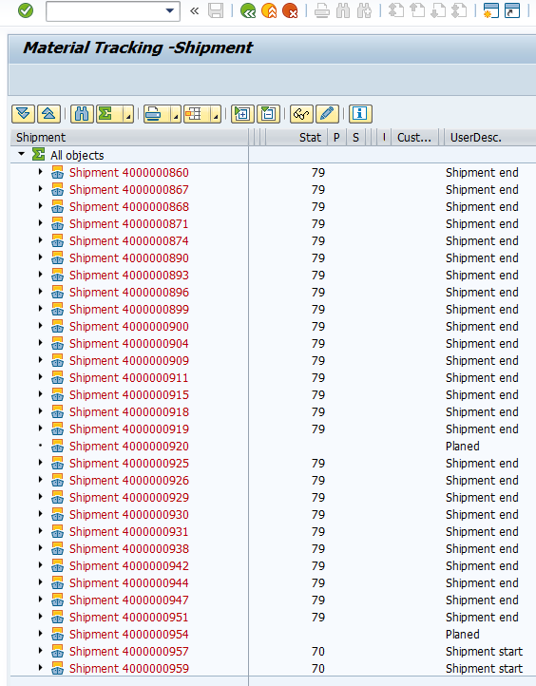
This should be the next screen-
These have been received already

These haven’t
Shipment Number - NOTE

Double click on the ‘shipment number’

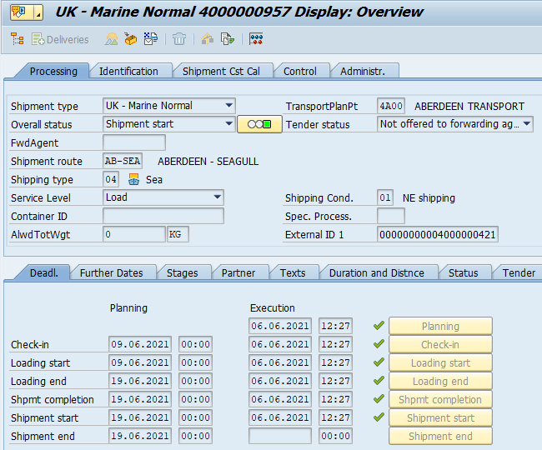
It opens an info window where you can check details
Clicking this will show you what is on the manifest so you can check it is the right one.

Note this number (4000000421) this is your voyage number

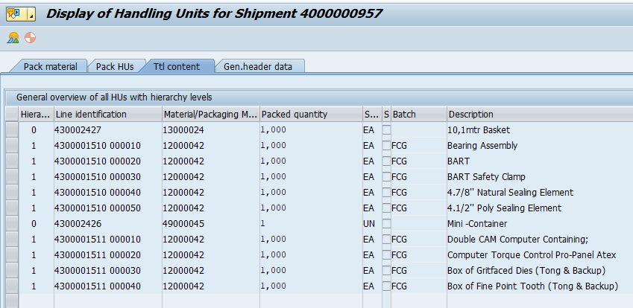
Once confirmed – you can receive it….
Use transaction o3o_VMIS
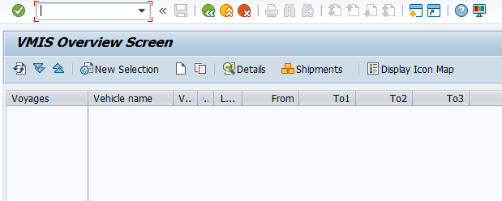
Click ‘new selection’
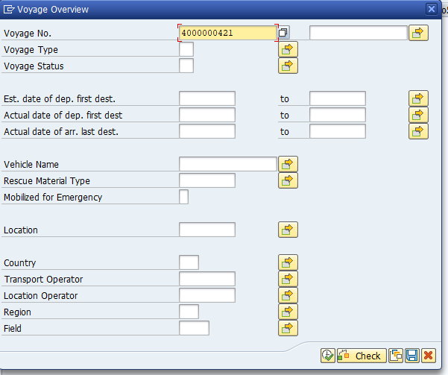
Enter your voyage number in there
Click Execute

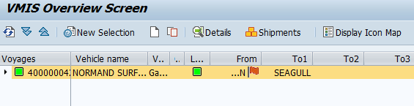
Double click the voyage number
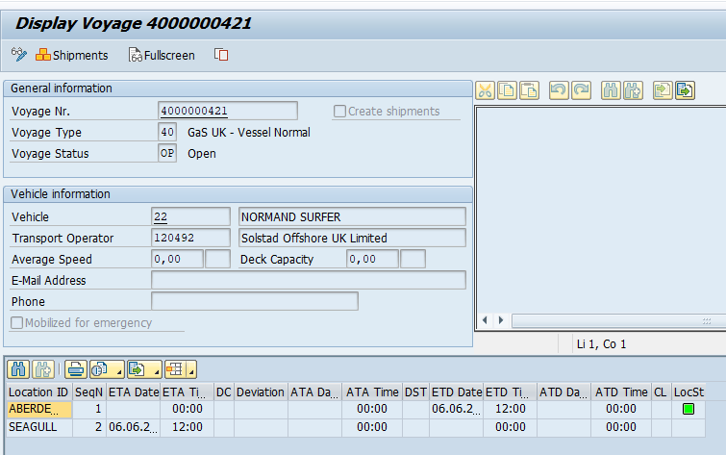
Click on shipments.
It will open the screen below which will have the corresponding “Shipment number”

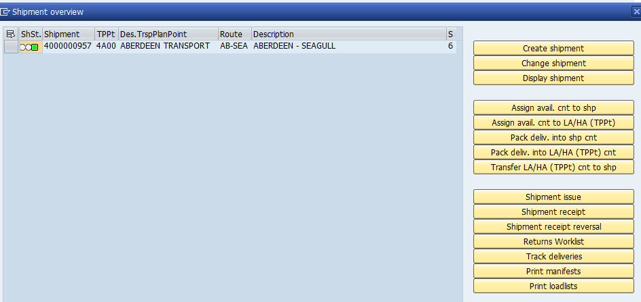
Click the box on the left, the line will highlight
then
Click ‘Shipment Receipt’

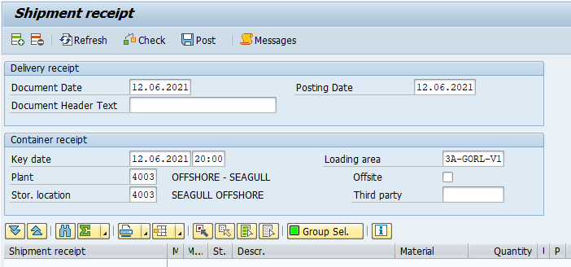
Click the Add Shipments button
Make sure dates are correct.
Enter 4003 in both ‘Plant’ & ‘Stor. Location’ (4003 is Us offshore) – Press ENTER
‘Loading area’ will open up and you put 3A-GORL-V1 in there

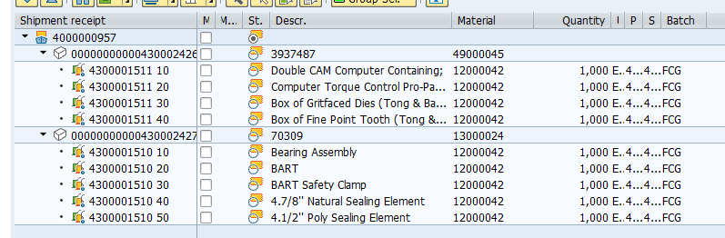
Click the small arrow to expand for more detail if you wish.
Click the tick box to select all, then click check.
You should get green boxes next to all lines.
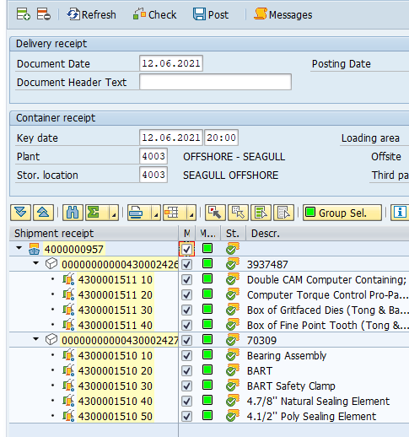
Click POST and ticks will appear after a short while
That’s it all receipted. Just to confirm if you re-open transaction o3o_sr10 you will see the shipment number is now marked “shipment end”.

